**Disease Spread Simulation (SIR Model)**

**Code-**

# Install necessary packages if not already installed

# install.packages(c("deSolve", "ggplot2", "reshape2", "shiny"))

library(deSolve)

library(ggplot2)

library(reshape2)

library(shiny)

# Define the SIR Model using differential equations

sir_model <- function(time, state, parameters) {

with(as.list(c(state, parameters)), {

dS <- -beta * S * I / N

dI <- beta * S * I / N - gamma * I

dR <- gamma * I

list(c(dS, dI, dR))

})

}

# Initial values for the system (S, I, R)

N <- 1000

init_state <- c(S = 999, I = 1, R = 0)

# Default parameters for beta and gamma

parameters <- c(beta = 0.3, gamma = 0.1)

# Time sequence for the simulation

times <- seq(0, 160, by = 1)

# Define UI for Shiny app

ui <- fluidPage(

titlePanel("SIR Model Simulation"),

sidebarLayout(

sidebarPanel(

sliderInput("beta", "Infection Rate (β):", min = 0, max = 1, value = 0.3, step = 0.01),

sliderInput("gamma", "Recovery Rate (γ):", min = 0, max = 1, value = 0.1, step = 0.01)

),

mainPanel(

plotOutput("sirPlot")

)

)

)

# Define server function for Shiny app

server <- function(input, output) {

output$sirPlot <- renderPlot({

# Update parameters based on slider input

params <- c(beta = input$beta, gamma = input$gamma)

# Solve the system with the current parameters

result <- ode(y = init_state, times = times, func = sir_model, parms = params)

# Convert the result to a data frame

df <- as.data.frame(result)

# Reshape the data for plotting

df_long <- melt(df, id = "time")

# Plot the SIR model output using ggplot2

ggplot(df_long, aes(x = time, y = value, color = variable)) +

geom_line(size = 1.2) +

labs(

title = "SIR Model Simulation",

x = "Time (days)",

y = "Number of Individuals",

color = "Compartment"

) +

theme_minimal()

})

}

# Run the Shiny app

shinyApp(ui = ui, server = server)

**graphs**

**Infection rate-0.53**

**Recovery rate-0.27**

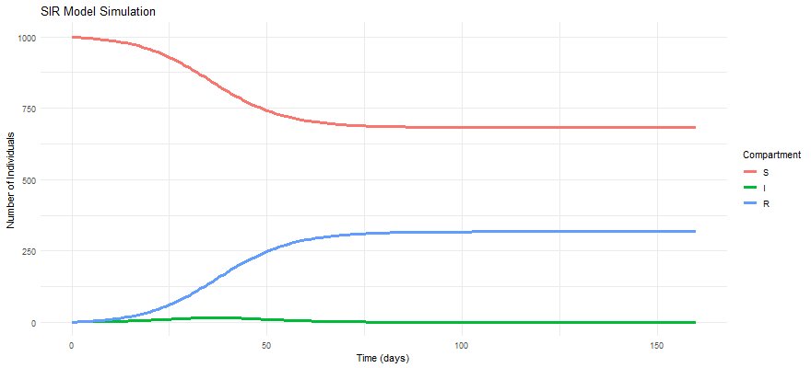

**infection rate-0.66**

**recovery rate-0.55**